**Surface Areas and Volumes**

1. A cuboid is a solid bounded by six rectangular plane regions. It has length, width and height.
2. A cuboid whose all edges are equal is called a cube.
3. A cylinder is a closed solid that has two parallel (usually circular) bases connected by a curved surface.
4. A cone is a solid that has a circular base and a single vertex.
5. A sphere is a perfectly round [geometrical](http://en.wikipedia.org/wiki/Geometrical) object in [three-dimensional space](http://en.wikipedia.org/wiki/Solid_geometry), such as the shape of a round [ball](http://en.wikipedia.org/wiki/Ball).
6. A hemisphere is half of a sphere.
7. Surface area of a solid is the sum of the areas of all its faces.
8. The total surface area of any object will be greater than its lateral surface area.
9. In case of a room, lateral surface area means the area of the four walls of the room, whereas total surface area means the area of four walls plus the area of the floor and the ceiling.
10. Volume is the space occupied by an object.
11. The unit of measurement of both volume and capacity is cubic unit such as cubic feet, cubic cm. cubic m etc.
12. If *l, b*, *h* denote respectively the length, breadth and height of a **cuboid**, then: Lateral surface area or Area of four walls = 2(*ℓ + b) h*

Total surface area = 2(*ℓb + bh + hℓ*) Volume = *ℓ x b x h*

*h*2

2  *b*2 

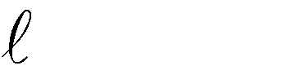

Diagonal of a cuboid =

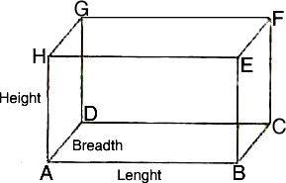

1. If the length of each edge of a **cube** is '*a*' units, then: Lateral surface area = 4 x (edge)2

Total surface area = 6 x (edge)² Volume = (edge)3

Diagonal of a cube = x edge



3

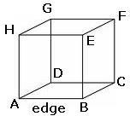

1. If *r* and *h* respectively denote the radius of the base and the height of a **right circular cylinder**, then: Area of each end or Base area = *r²*

Area of curved surface or lateral surface area = perimeter of the base x height = *2 rh*

Total surface area (including both ends) = *2rh + 2r² = 2r (h + r)*

Volume = Area of the base x height = r²h

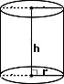

1. If *R* and *r* respectively denote the external and internal radii of a **right circular hollow cylinder** and *h*

denotes its height, then:

Area of each circular base = *R²* - *r²*

Area of curved surface = *2*(*R + r*)*h*

Total surface area = (External surface) + (Internal surface)

*= (2Rh + 2rh) + 2 (R² - r²)*

Volume of = (External volume) – (Internal volume)

= *(R²h - r²h) = h (R² - r²)*

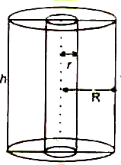

1. If *r*, *h* and *l* respectively denote the radius, height and slant height of a **right circular cone**, then: Slant height (*ℓ*) =

Area of curved surface = *rℓ = r*

*h*2  *r* 2

*h*2  *r* 2

Total surface area = Area of curved surface + Area of base = *rℓ + r² = r (ℓ + r)*

Volume =

1 * r* 2*h*

3

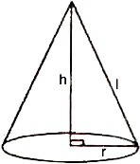

1. If r is the radius of a **sphere**, then: Surface area = 4*r²*

Volume =

4 * r* 3

3

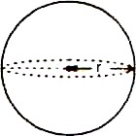

1. If r is the radius of a **hemisphere**, then: Area of curved surface = 2*r²*

Total surface Area = Area of curved surface + Area of base

= *2r² + r²*

*= 3r²*

Volume =

2 * r* 3

3

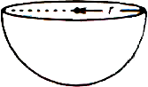

1. Volume of water flown in the tank in one hour = (area of cross section of the aperture) *×* (speed in meters per hour)
2. When an object of certain volume is recast into a cylinder, the volume of the cylinder formed will always be equal to the volume of the original object.
3. The solids having the same curved surface do not necessarily occupy the same volume.
4. When an object is dropped into a liquid, the volume of the displaced liquid is equal to the volume of the object that is dipped.
5. Of all the solids having a given volume, the sphere is the one with the smallest surface area. Of all solids having a given surface area, the sphere is the one having the greatest volume.